The CallVU Digital Engagement Platform (CDEP)

on the AWS Cloud

Quick Start Reference Deployment

March 2019

*<Partner Organization>*

*AWS Quick Start Team*

Contents

Quick Links 2

Overview 2

CDEP on AWS 3

Costs and Licenses 3

Architecture 3

Prerequisites 5

Specialized Knowledge 5

Technical Requirements 5

Deployment Options 5

Deployment Steps 5

Step 1. Prepare Your AWS Account 5

Step 2. Subscribe to the CDEP AMI 6

Step 3. Launch the Quick Start 6

Step 4. Test the Deployment 10

Best Practices Using CDEP on AWS 10

Security 10

<Other Useful Information> 10

FAQ 10

GitHub Repository 11

Additional Resources 11

Document Revisions 12

This Quick Start was created by CallVU in collaboration with Amazon Web Services (AWS).

[Quick Starts](http://aws.amazon.com/quickstart/) are automated reference deployments that use AWS CloudFormation templates to deploy key technologies on AWS, following AWS best practices.

## Quick Links

The links in this section are for your convenience. Before you launch the Quick Start, please review the architecture, security, and other considerations discussed in this guide.

* If you have an AWS account, and you’re already familiar with AWS services and CDEP, you can launch the Quick Start to build the architecture shown in Figure 1 in a new or existing virtual private cloud (VPC). The deployment takes approximately 1.5 hour. If you’re new to AWS or to CDEP, please review the implementation details and follow the step-by-step instructions provided later in this guide.
* If you want to take a look under the covers, you can view the AWS CloudFormation templates that automate the deployment.

## Overview

[**Launch   
(for**](https://console.aws.amazon.com/cloudformation/home?region=us-west-2#cstack=sn%7Estack-name%7Cturl%7Ehttps://s3.amazonaws.com/qs-bucket-callvu/callvu-connect/templates/callvu-connect-master.template) **new VPC)**

This Quick Start reference deployment guide provides step-by-step instructions for deploying CDEP on the AWS Cloud.

[**View template**](https://s3.amazonaws.com/qs-bucket-callvu/callvu-connect/templates/callvu-connect-master.template)

**(for new VPC)**

This Quick Start is for customers that operate contact centers of any size.

### CDEP on AWS

Brief description of software and its use, include the benefits of using the software on AWS + usage scenarios can be found [here](https://s3.amazonaws.com/qs-bucket-callvu/callvu-connect/documentation/The+CallVU+Solution+For+AWS+Quickstart.docx).

### Costs and Licenses

You are responsible for the cost of the AWS services used while running this Quick Start reference deployment. There is no additional cost for using the Quick Start.

The AWS CloudFormation template for this Quick Start includes configuration parameters that you can customize. Some of these settings, such as instance type, will affect the cost of deployment. For cost estimates, see the pricing pages for each AWS service you will be using. Prices are subject to change.

**Tip** After you deploy the Quick Start, we recommend that you enable the [AWS Cost and Usage Report](https://docs.aws.amazon.com/awsaccountbilling/latest/aboutv2/billing-reports-gettingstarted-turnonreports.html) to track costs associated with the Quick Start. This report delivers billing metrics to an S3 bucket in your account. It provides cost estimates based on usage throughout each month, and finalizes the data at the end of the month. For more information about the report, see the [AWS documentation](https://docs.aws.amazon.com/awsaccountbilling/latest/aboutv2/billing-reports-costusage.html).

*Provide information about licensing requirements for the product being deployed.*

## Architecture

Deploying this Quick Start for a new virtual private cloud (VPC) with **default parameters** builds the following CDEP environment in the AWS Cloud.

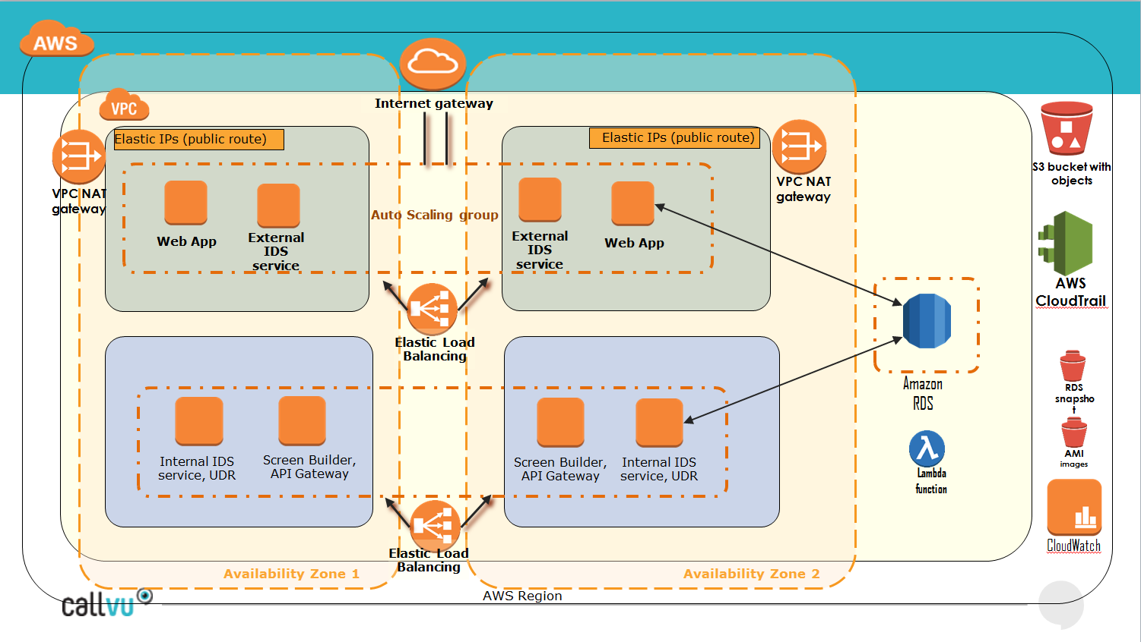

Figure 1: Quick Start architecture for *CDEP* on AWS

The Quick Start sets up the following:

* A highly available architecture that spans two Availability Zones.*
* A VPC configured with public and private subnets according to AWS best practices, to provide you with your own virtual network on AWS.*
* An internet gateway to allow access to the internet. This gateway is used by the bastion hosts to send and receive traffic.*
* In the public subnets, managed NAT gateways to allow outbound internet access for resources in the private subnets.*
* In the public subnets, a Windows bastion host in an Auto Scaling group with Application Load Balancer listening HTTP + HTTPS protocols to allow inbound Secure Shell (SSH),Remote desktop (RDP) access to EC2 instances created from pre-built AMI's in public subnets.*
* In the private subnets, a Windows bastion host in an Auto Scaling group with Application Load Balancer listening HTTP protocol to allow inbound Remote desktop (RDP) access to EC2 instances created from pre-built AMI's in private subnets from public subnets.
* Lambda Function named CallVuHub to bridge between AmazonConnect and this environment EC2 instances plus IAM Role for CallVuHub function allowing access to VPC subnets.
* Send_SMS user created for relevant region allowed only to send SMS configured by custom policy . CallVuHub Lambda will use its credentials to send link from Amazon Connect to the caller’s mobile device.
* CloudTrail system with TrailLogGroup to save events to S3 Bucket. S3 bucket may be default or chosen by the end user. Log retention period may be configures as well as the email address to receive alerts and notifications.
* RDS DBInstance with MySql Standard edition built from predesigned snapshot.
* Notification topic to send alerts (basic alerts configured in quick-start, can be extended by the end user) to the operator’s email.

## Prerequisites

### Technical Requirements

This quick start supported only in regions where Amazon Connect is available.

* Client has to configure https certificate for DNS which will be used to access the public servers.
* Public and private AutoScale groups build Windows 2016 Server AMI based EC2 instances. Up to 3 instances per subnet are created dependent on CPU usage. The instance type can be chosen by user, but it is strongly recommended to use the type set as default by CallVU.
* DBInstance is MySQL Standard Edition server with license included with engine version 14.00.3035.2.v1. Initiation of this server is made from a pre-built snapshot. DBClass may be changed, but have to meet Standard Edition requirements.
* For the visual IVR implementation, an AmazonConnect working system is required.
* KeyPair (.pem files) to access to servers have to be configured prior to running the template.
* At least one (2 different preferred) email account have to be ready to receive notifications, alerts and CloudTrail events (for CloudTrail it is recommended to use a separate email due to large amount of events).

*AWS account configuration, operating system, licensing, DNS, etc. requirements*

### Specialized Knowledge

Before you deploy this Quick Start, we recommend that you become familiar with the following AWS services. (If you are new to AWS, see [Getting Started with AWS](https://aws.amazon.com/getting-started/).)

* [Amazon EC2](https://aws.amazon.com/documentation/ec2/)
* [Amazon RDS](https://docs.aws.amazon.com/rds/index.htm)
* [Amazon EBS](https://docs.aws.amazon.com/AWSEC2/latest/UserGuide/AmazonEBS.html)
* [Amazon VPC](https://aws.amazon.com/documentation/vpc/)
* [AWS CloudFormation](https://aws.amazon.com/documentation/cloudformation/)

* [AWS CLI (Command Line Interface).](https://s3.amazonaws.com/qs-bucket-callvu/callvu-connect/documentation/AWS+Visual+Connect+manual.docx)
* [Amazon Connect (Create flows and associate with phone numbers).](https://s3.amazonaws.com/qs-bucket-callvu/callvu-connect/documentation/AWS+Visual+Connect+manual.docx)
* [AWS Visual Connect.](https://s3.amazonaws.com/qs-bucket-callvu/callvu-connect/documentation/AWS+Visual+Connect+manual.docx)

## Deployment Options

This Quick Start provides this deployment option:

* **Deploy** CDEP **into a new VPC** (end-to-end deployment). This option builds a new AWS environment consisting of the VPC, subnets, NAT gateways, security groups, bastion hosts and other infrastructure components, then deploys CDEP into this new VPC.

The Quick Start provides separate templates for these options. It also lets you configure CIDR blocks, instance types, and CDEP settings, as discussed later in this guide.

## Deployment Steps

### Step 1. Prepare Your AWS Account

1. If you don’t already have an AWS account, create one at <https://aws.amazon.com> by following the on-screen instructions.
2. Use the region selector in the navigation bar to choose the AWS Region where you want to deploy CDEP on AWS. The supported regions are: N. Virginia, Ohio, Oregon, Frankfurt, Sydney.
3. Create a [key pair](https://docs.aws.amazon.com/AWSEC2/latest/UserGuide/ec2-key-pairs.html) in your selected region (or use existing one).
4. Create new or find existing certificate issued to your domain.
5. If necessary, [request a service limit increase](https://console.aws.amazon.com/support/home#/case/create?issueType=service-limit-increase&limitType=service-code-) for the Amazon EC2 EIP,Internet Gateway instance type. You might need to do this if you already have an existing deployment that uses this instance type and you think you may exceed the [default limit](http://docs.aws.amazon.com/AWSEC2/latest/UserGuide/ec2-resource-limits.html) with this deployment.

### Step 2. Launch the Quick Start

**Note** You are responsible for the cost of the AWS services used while running this Quick Start reference deployment. There is no additional cost for using this Quick Start. For full details, see the pricing pages for each AWS service you will be using in this Quick Start. Prices are subject to change.

1. Choose one of the following options to launch the AWS CloudFormation template into your AWS account. For help choosing an option, see deployment options earlier in this guide.

|  |
| --- |
| Option 1  **[Launch](https://console.aws.amazon.com/cloudformation/home?region=us-west-2" \l "cstack=sn%7Estack-name%7Cturl%7Ehttps://s3.amazonaws.com/qs-bucket-callvu/callvu-connect/templates/callvu-connect-master.template)**  Deploy CDEP into a  new VPC on AWS |

**Important** If you’re deploying CDEP into an existing VPC, make sure that your VPC has two private subnets in different Availability Zones for the database instances. These subnets require [NAT gateways or NAT instances](http://docs.aws.amazon.com/AmazonVPC/latest/UserGuide/vpc-nat.html) in their route tables, to allow the instances to download packages and software without exposing them to the internet. You will also need the domain name option configured in the DHCP options as explained in the [Amazon VPC documentation](http://docs.aws.amazon.com/AmazonVPC/latest/UserGuide/VPC_DHCP_Options.html). You will be prompted for your VPC settings when you launch the Quick Start.

Each deployment takes about 1-2 hours to complete.

1. Check the region that’s displayed in the upper-right corner of the navigation bar, and change it if necessary. This is where the network infrastructure for CDEP will be built. The template is launched in the US East (Ohio) Region and all regions supported by Amazon Connect .
2. On the **Select Template** page, keep the default setting for the template URL, and then choose **Next**.
3. On the **Specify Details** page, change the stack name if needed. Review the parameters for the template. Provide values for the parameters that require input. Explanation about each parameter can be found here :  
     
   a.   
     
   Stack name, choose your own name, this name will be appended to most of the created sources.
4. 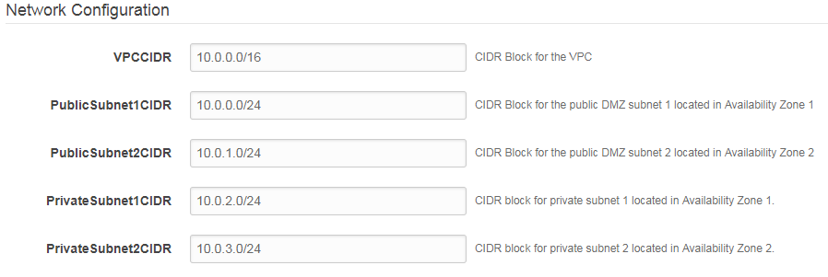  
   New VPC configurations, it is recommended to use default values.
5. 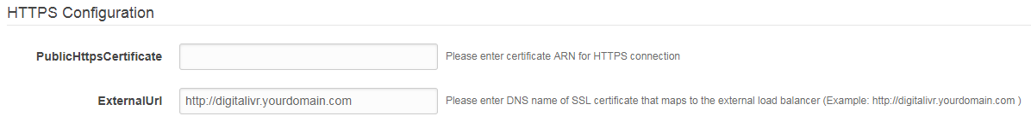  
   Input your certificate ARN pre-configured to work with the ExternalUrl specified after.
6. 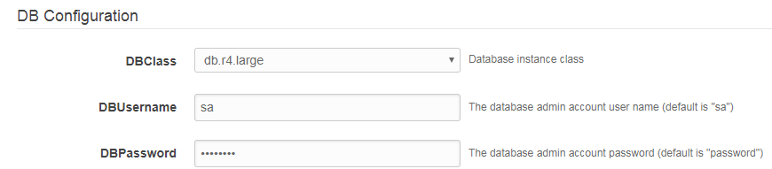  
   Choose DB size depending on your estimations, set the user name and password or leave as defaults.
7. 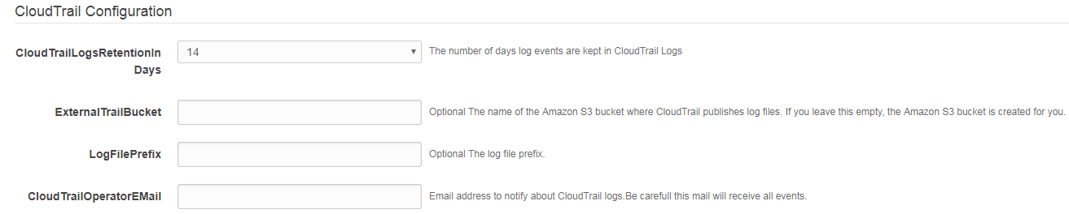  
   CloudTrail configuration: Created for launch region only, retention days can be chosen up to 10 years, 2 optional fields for S3 bucket name and log files prefix.  
   Email for CloudTrail suggested to be not the main one cause it receives all events that happen in Trail.
8. 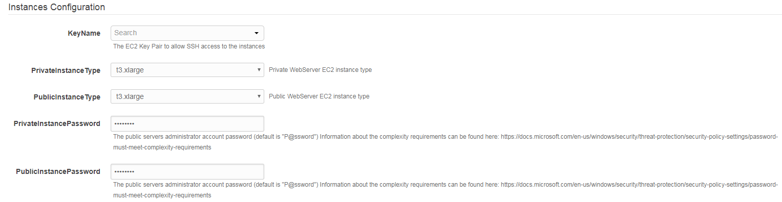  
   Instances Configuration: Choose pre-defined or existing KeyName, Instance type. It is suggested to leave the default values. Passwords HAVE to fit complexity requirements.
9. 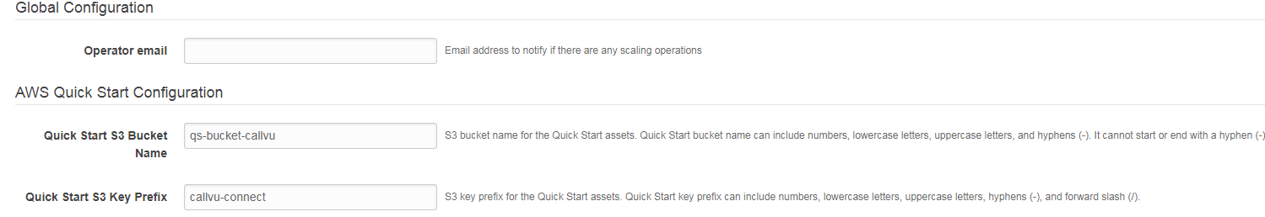  
   Global Configuration: Operator email – this email will receive alerts about auto scale up/down events.  
   AWS QS Configuration: Leave default values. Can be changed in special cases or if default path unavailable.   
     
     
   For all other parameters, review the default settings and customize them as necessary. When you finish reviewing and customizing the parameters, choose **Next**.

In the following tables, parameters are listed by category and described separately for the two deployment options:

* Parameters for deploying CDEP into a new VPC

**Option 1: Parameters for deploying CDEP into a new VPC**

[View template](https://s3.amazonaws.com/quickstart-reference/)

*<The following parameter tables are generated automatically from the templates. Don’t enter the parameter information manually. The information below is provided only as an example. We recommend that you use these group and parameter labels if you’re providing similar functionality in your CloudFormation templates. For parameter naming guidelines, see the* [*Contributor’s Guide*](https://aws-quickstart.github.io/naming-parms.html)*.>*

*VPC Network Configuration:*

|  |  |  |
| --- | --- | --- |
| Parameter label (name) | Default | Description |
| Availability Zones (AvailabilityZones) | *Two first available zones of region chosen automatically.* | The list of Availability Zones to use for the subnets in the VPC. The Quick Start uses two Availability Zones from your list and preserves the logical order you specify. |
| VPC CIDR (VPCCIDR) | 10.0.0.0/16 | The CIDR block for the VPC. |
| Private Subnet 1 CIDR (PrivateSubnet1CIDR) | 10.0.1.0/24 | The CIDR block for the private subnet located in Availability Zone 1. Up to 254 hosts. |
| Private Subnet 2 CIDR (PrivateSubnet2CIDR) | 10.0.2.0/24 | The CIDR block for the private subnet located in Availability Zone 2. . Up to 254 hosts. |
| Public Subnet 1 CIDR (PublicSubnet1CIDR) | 10.0.3.0/24 | The CIDR block for the public (DMZ) subnet located in Availability Zone 1. . Up to 254 hosts. |
| Public Subnet 2 CIDR (PublicSubnet2CIDR) | 10.0.4.0/24 | The CIDR block for the public (DMZ) subnet located in Availability Zone 2. . Up to 254 hosts. |

*HTTPS Configuration:*

|  |  |  |
| --- | --- | --- |
| Parameter label (name) | Default | Description |
| PublicHttpsCertificate | *Certificate ARN Requires input* | Certificate issued to end user fits external URL |
| ExternalURL | http://digitalivr.yourdomain.com | External URL Domain name to access public Servers Load Balancer. |

*DB Configuration:*

|  |  |  |
| --- | --- | --- |
| Parameter label (name) | Default | Description |
| DBClass | *Db.r4.large* | Choose DBClass (only supported classes appear in list) |
| DBUserName | sa | Set DB master user. |
| DBPassword | password | Set DB master user password |

*CloudTrail Configuration:*

|  |  |  |
| --- | --- | --- |
| Parameter label (name) | Default | Description |
| CloudTrailLogsRetentionInDays | *14* | The number of days log events are kept in CloudTrail Logs |
| ExternalTrailBucket | <Empty> | Optional The name of the Amazon S3 bucket where CloudTrail publishes log files. If you leave this empty, the Amazon S3 bucket is created for you. |
| CloudTrailOperatorEMail | <Empty> | EMail address to notify about CloudTrail logs.Be carefull this mail will receive all events |

*Amazon EC2 Configuration:*

|  |  |  |
| --- | --- | --- |
| Parameter label (name) | Default | Description |
| Key Name (KeyPairName) | *Requires input* | A public/private key pair, which allows you to connect securely to your instance after it launches. When you created an AWS account, this is the key pair you created in your preferred region. |
| PrivateInstanceType | *t3.xlarge* | Private WebServer EC2 instance type |
| PublicInstanceType | *t3.xlarge* | Public WebServer EC2 instance type |

*Global Configuration:*

|  |  |  |
| --- | --- | --- |
| Parameter label (name) | Default | Description |
| OperatorEMail | *Requires input* | Email address to notify if there are any scaling operations |

*AWS Quick Start Configuration:*

|  |  |  |
| --- | --- | --- |
| Parameter label (name) | Default | Description |
| Quick Start S3 Bucket Name (QSS3BucketName) | aws-quickstart | The S3 bucket you have created for your copy of Quick Start assets, if you decide to customize or extend the Quick Start for your own use. The bucket name can include numbers, lowercase letters, uppercase letters, and hyphens, but should not start or end with a hyphen. |
| Quick Start S3 Key Prefix (QSS3KeyPrefix) | quickstart-callvu-connect/ | The [S3 key name prefix](https://docs.aws.amazon.com/AmazonS3/latest/dev/UsingMetadata.html) used to simulate a folder for your copy of Quick Start assets, if you decide to customize or extend the Quick Start for your own use. This prefix can include numbers, lowercase letters, uppercase letters, hyphens, and forward slashes. |

* **Option 2: Parameters for deploying** CDEP **into an existing VPC**

**Not Available.**

1. On the **Options** page, you can [specify tags](https://docs.aws.amazon.com/AWSCloudFormation/latest/UserGuide/aws-properties-resource-tags.html) (key-value pairs) for resources in your stack and [set advanced options](https://docs.aws.amazon.com/AWSCloudFormation/latest/UserGuide/cfn-console-add-tags.html). When you’re done, choose **Next**.
2. On the **Review** page, review and confirm the template settings. Under **Capabilities**, select the check box to acknowledge that the template will create IAM resources.
3. Choose **Create** to deploy the stack.
4. Monitor the status of the stack. When the status is **CREATE_COMPLETE**, the CDEP cluster is ready.
5. Use the URLs displayed in the **Outputs** tab for the stack to view the resources that were created.

### Step 4. Test the Deployment

To test the deployment follow steps described in "[The CallVU Solution For AWS QuickStart](https://s3.amazonaws.com/qs-bucket-callvu/callvu-connect/documentation/The+CallVU+Solution+For+AWS+Quickstart.docx)" Step 4.

## Best Practices Using CDEP on AWS Connect

For the best practices please follow this manual: "[AWS Visual Connect Manual](https://s3.amazonaws.com/qs-bucket-callvu/callvu-connect/documentation/AWS+Visual+Connect+manual.docx)"

## Security

The environment separated to subnets in its own VPC. External subnet secured by Amazon Security Group. The access to the internal servers is not allowed from the internet. All passwords are set on Formation launch and they are unique per client. Database doesn't have a public access at all. All interactions with the private servers and database can be made only from public servers after login. Lambda function, Send SMS User and CloudTrail are allowed to perform only specified actions required by the system and is set up in Polices and Rules.

## <Other Useful Information>

*Provide any other information of interest to users, especially focusing on areas where AWS or cloud usage differs from on-premises usage.*

## FAQ

*Any tips or answers to anticipated questions. This could include the following troubleshooting information. If you don’t have any other Q&A to add, change this heading to “Troubleshooting” and remove the Q/A headings below.*

**Q.** I encountered a CREATE_FAILED error when I launched the Quick Start.

**A.** If AWS CloudFormation fails to create the stack, we recommend that you relaunch the template with **Rollback on failure** set to **No**. (This setting is under **Advanced** in the AWS CloudFormation console, **Options** page.) With this setting, the stack’s state will be retained and the instance will be left running, so you can troubleshoot the issue. (Look at the log files in %ProgramFiles%\Amazon\EC2ConfigService and C:\cfn\log.)

**Important** When you set **Rollback on failure** to **No**, you will continue to incur AWS charges for this stack. Please make sure to delete the stack when you finish troubleshooting.

For additional information, see [Troubleshooting AWS CloudFormation](https://docs.aws.amazon.com/AWSCloudFormation/latest/UserGuide/troubleshooting.html) on the AWS website.

**Q.** I encountered a size limitation error when I deployed the AWS CloudFormation templates.

**A.** We recommend that you launch the Quick Start templates from the links in this guide or from another S3 bucket. If you deploy the templates from a local copy on your computer or from a non-S3 location, you might encounter template size limitations when you create the stack. For more information about AWS CloudFormation limits, see the [AWS documentation](http://docs.aws.amazon.com/AWSCloudFormation/latest/UserGuide/cloudformation-limits.html).

## GitHub Repository

You can visit our [GitHub repository](https://github.com/aws-quickstart/tbd) to download the templates and scripts for this Quick Start, to post your comments, and to share your customizations with others.

## Additional Resources

*Additional reading, with full URLs. Revise the following as appropriate.*

**AWS services**

* Amazon EBS  
  <https://docs.aws.amazon.com/AWSEC2/latest/UserGuide/AmazonEBS.html>
* Amazon EC2  
  <https://aws.amazon.com/documentation/ec2/>
* Amazon VPC  
  <https://aws.amazon.com/documentation/vpc/>
* AWS CloudFormation  
  <https://aws.amazon.com/documentation/cloudformation/>

**CDEP documentation**

* All needed documentation can be found here: [CDEP Documentation folder](https://s3.console.aws.amazon.com/s3/buckets/qs-bucket-callvu/callvu-connect/documentation/)

**Quick Start reference deployments**

* AWS Quick Start home page  
  <https://aws.amazon.com/quickstart/>

## Document Revisions

|  |  |  |
| --- | --- | --- |
| Date | Change | In sections |
| March 2019 | *Brief description of change. Formatting and minor text changes don’t warrant any mention; major additions and changes do.* | *Links to revised sections* |
| April 2019 | Initial publication | — |

© 2019, Amazon Web Services, Inc. or its affiliates, and CallVU All rights reserved.

**Notices**

This document is provided for informational purposes only. It represents AWS’s current product offerings and practices as of the date of issue of this document, which are subject to change without notice. Customers are responsible for making their own independent assessment of the information in this document and any use of AWS’s products or services, each of which is provided “as is” without warranty of any kind, whether express or implied. This document does not create any warranties, representations, contractual commitments, conditions or assurances from AWS, its affiliates, suppliers or licensors. The responsibilities and liabilities of AWS to its customers are controlled by AWS agreements, and this document is not part of, nor does it modify, any agreement between AWS and its customers.

The software included with this paper is licensed under the Apache License, Version 2.0 (the "License"). You may not use this file except in compliance with the License. A copy of the License is located at <http://aws.amazon.com/apache2.0/> or in the "license" file accompanying this file. This code is distributed on an "AS IS" BASIS, WITHOUT WARRANTIES OR CONDITIONS OF ANY KIND, either express or implied. See the License for the specific language governing permissions and limitations under the License.